Name: Mohamed Elmorsy

Batch code: LISUM11

Submission date: 11-Aug-2022

Submitted to: Data Glacier

Snapshots of deployment steps:

1. Run App python code

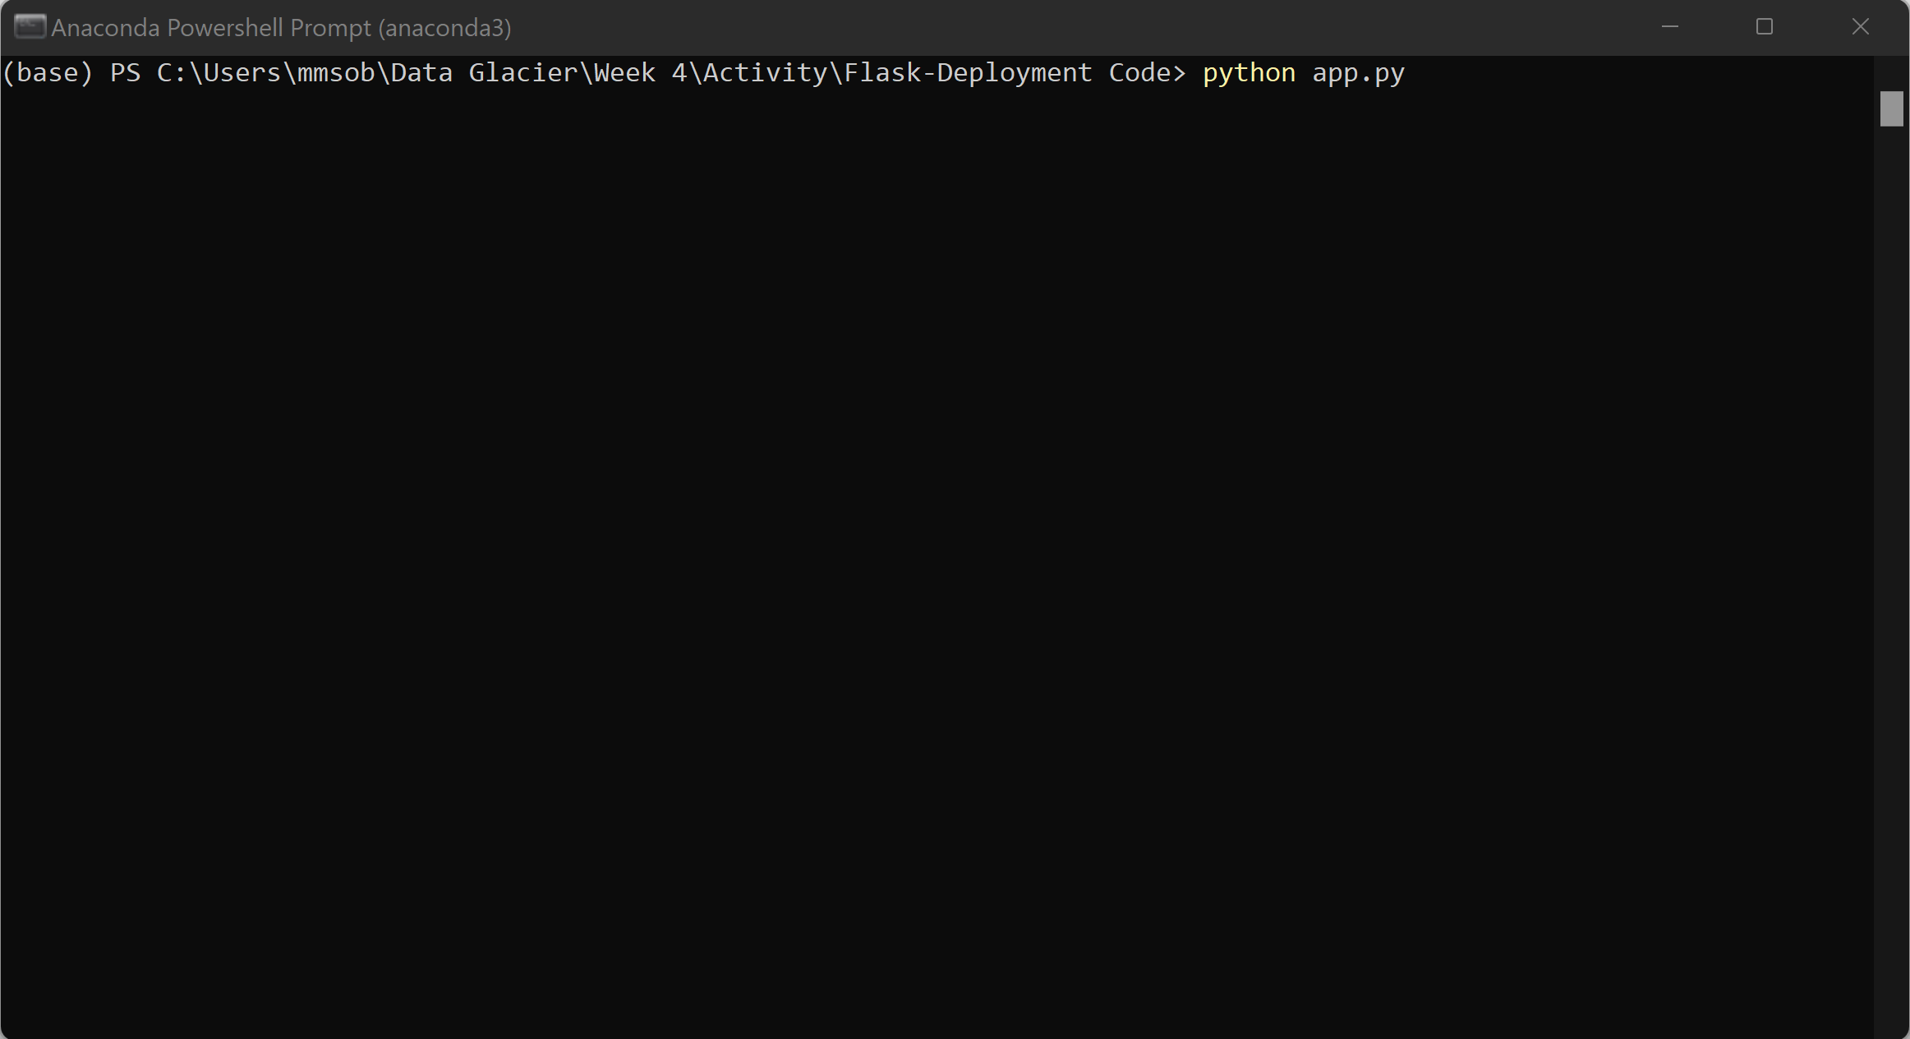

1. Get local server URL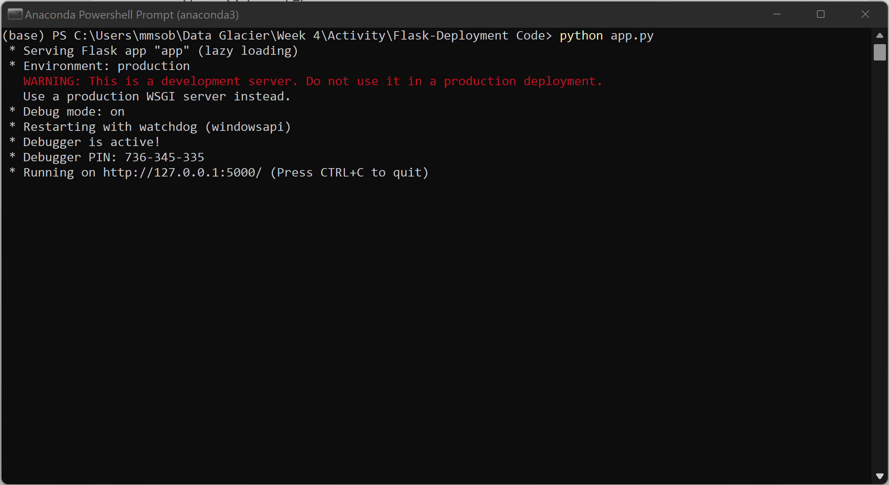
2. View App

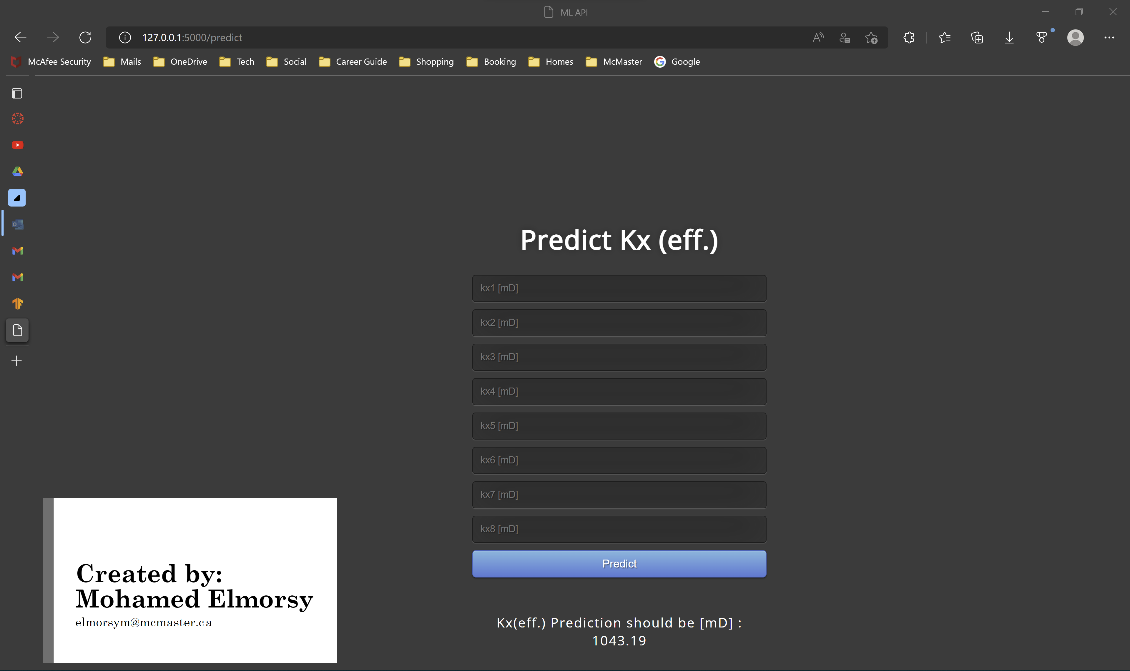

1. Make Predictions

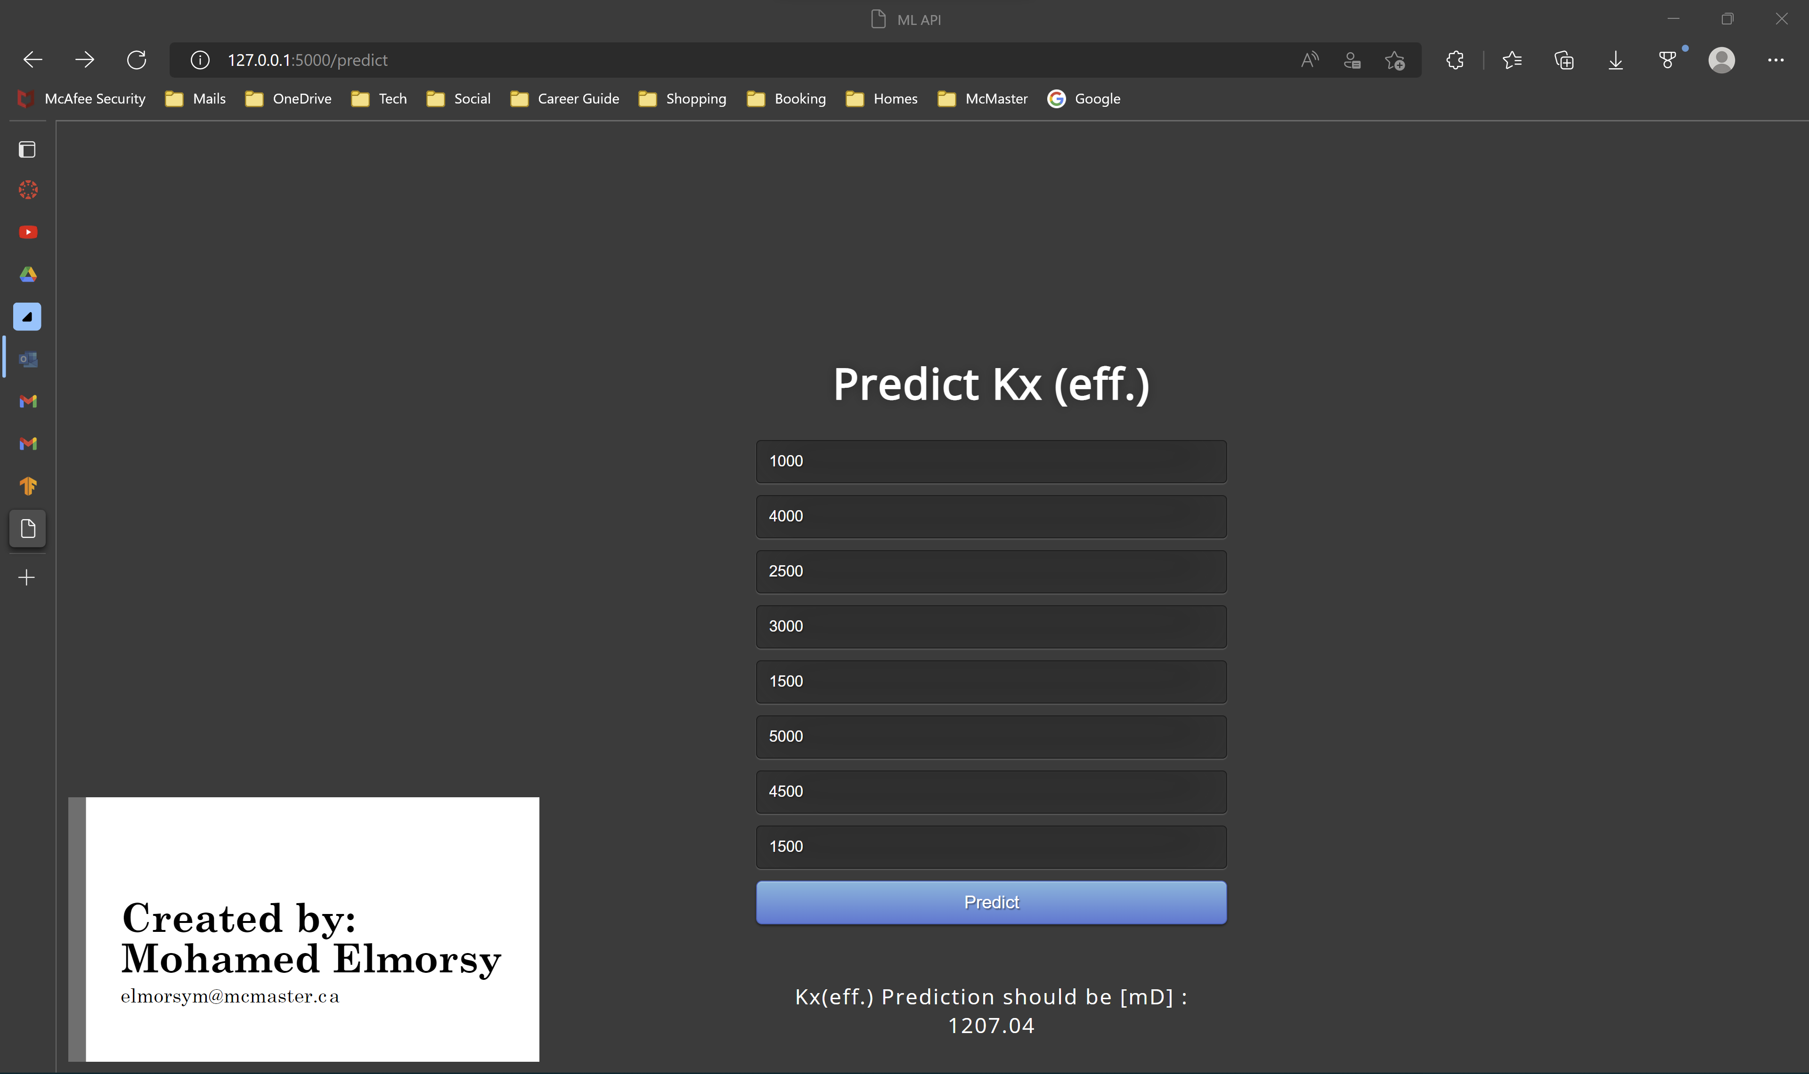

Thank you!